# HOL 5 : Deploying Sample application on kubernetes cluster

**Objective:**

**Learn deployment of an application on kubernetes using kubectl command-line, explore dashboard.**

**Duration: 30 Minutes**

**Prerequisites:**

1. Azure Subscription
2. Internet Connection
3. SSH Client (Ubuntu Bash or Git Bash)
4. Web Browser (Any)
5. Text editor (Visual Studio code recommended)

**Steps:**

1. Launch Azure VM and Start the (Previously stopped) cluster.
2. From Azure portal, goto DockerVM2 and Click “Start” to Start VM
3. Once VM Started, connect using SSH
4. Once connected, use following command to start the existing cluster

$ sudo minikube start

$ sudo minikube status

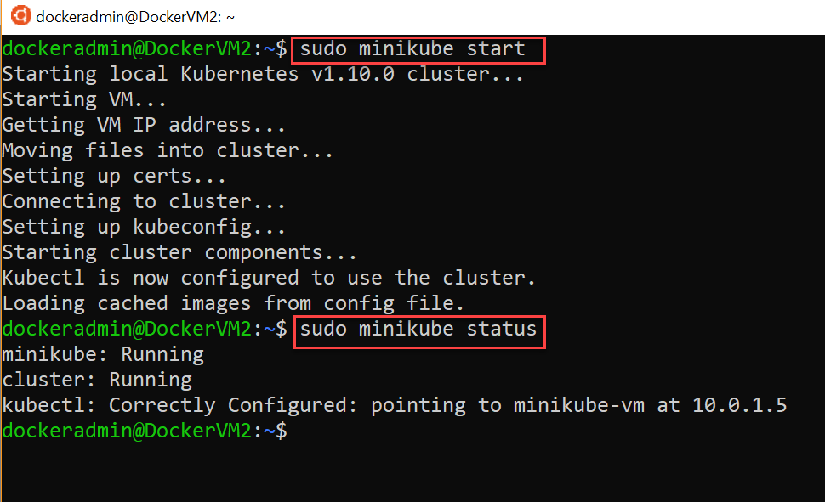

1. Deploying Sample Application
2. Download the deployment.yml file from given URL:

$ wget <https://raw.githubusercontent.com/mahendra-shinde/k8s-demos/master/deployment.yml>

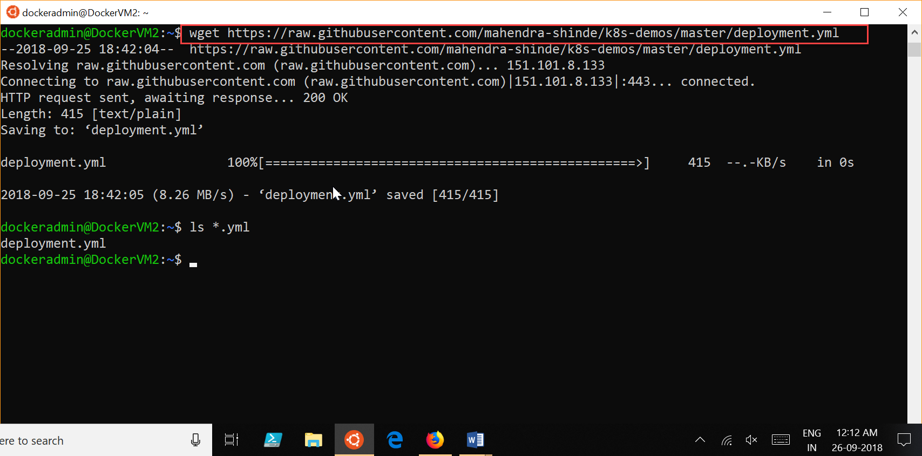

1. To start deployment try following command:

$ sudo kubectl apply -f deployment.yml

$ sudo kubectl get deployments

$ sudo kubectl get pods

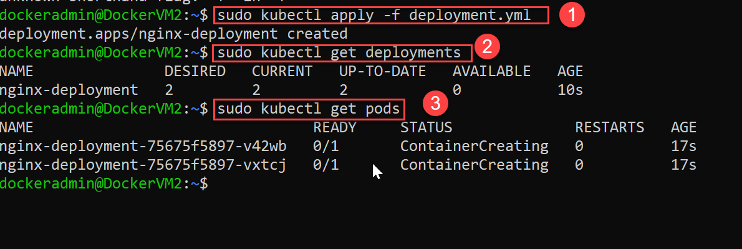

1. Lets try scaling the deployment

$ sudo kubectl scale --replicas=4 -f deployment.yml

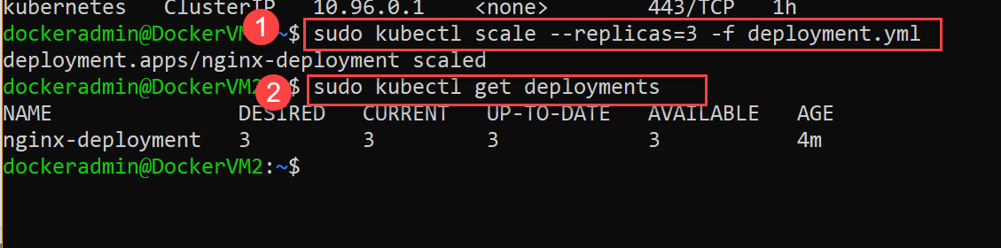

1. Test the deployment of dashboard

$ sudo minikube dashboard

Open web browser and access URL : <VM-Public-Ip>:30000

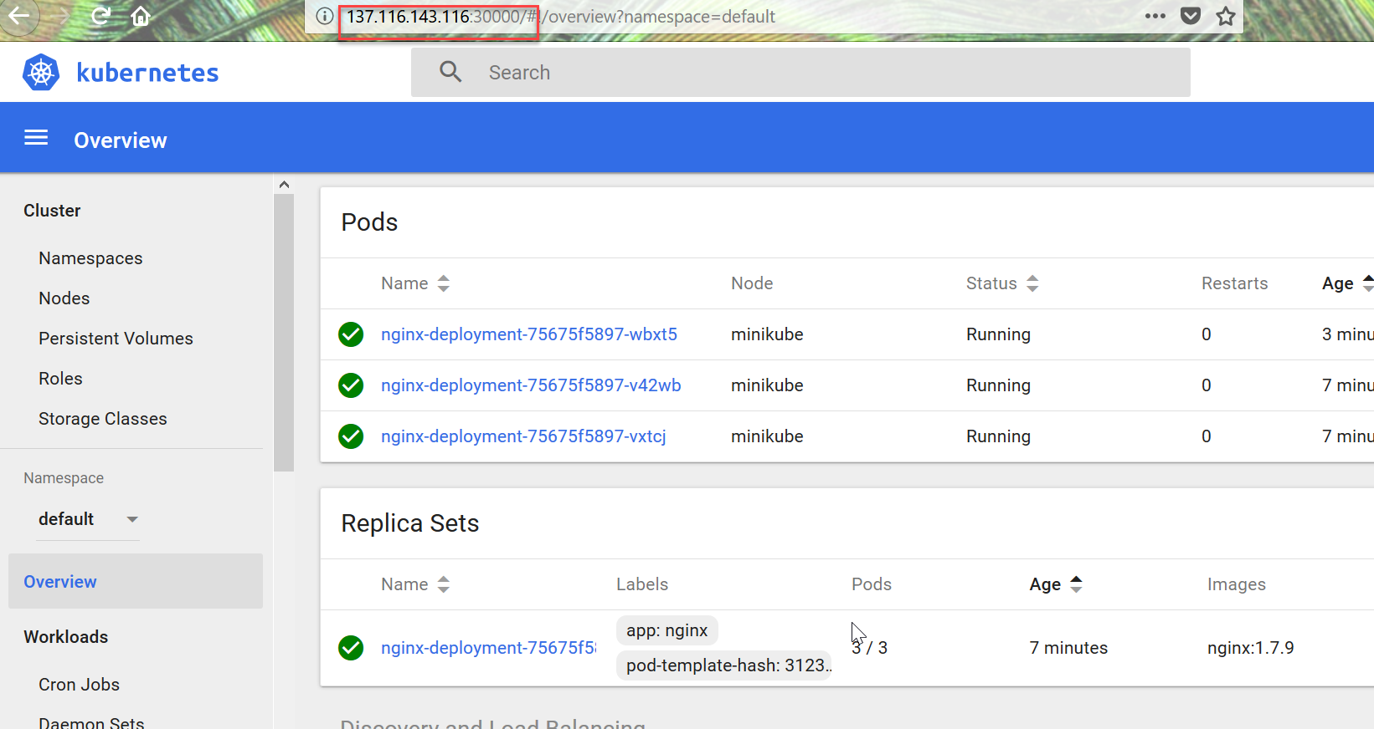

Feel free to explore the dashboard further.

Clean Up: Shutdown the minikube cluster using following command before VM shuts down:

$ sudo minikube stop